**CSE 212 – Programming with Data Structures**

**W01 Prove – Response Document**

|  |  |
| --- | --- |
| **Name:** | Chris Bagwell |
| **Date:** | 9/15/2022 |
| **Teacher:** | Bro. Zachariah Alvey |

*It is a violation of BYU-Idaho Honor Code to post or share this document with others or to post it online. Storage into a personal and private repository (e.g. private GitHub repository, unshared Google Drive folder) is acceptable.*

**Question 1: For the rotate right problem, provide a description of how you solved the problem.**

I started out think that no matter how the array is split it will always be split in 2. I thought that I just need to take the first half and either store it in a temporary array or have it separated from the original array. I would then re-define the original array with the second half in place of the first half. While I figured I can just re-define the original array, I thought why have a second array, just use the slicing to swap the 2 parts of the array. So, I looked at the assignment and discovered I was passed in a list and an amount. I figured I can use the amount like such ( array[:length – amount] and array[length – amount:] that would get the fist part and the second part respectively. I then had to find out a solution to the scenario that some one puts in an amount bigger than elements in the array. The assignment had a hint about using % to figure for the wrapping.

**Question 2: For the rotate right problem, draw a picture of how you solved the problem.**

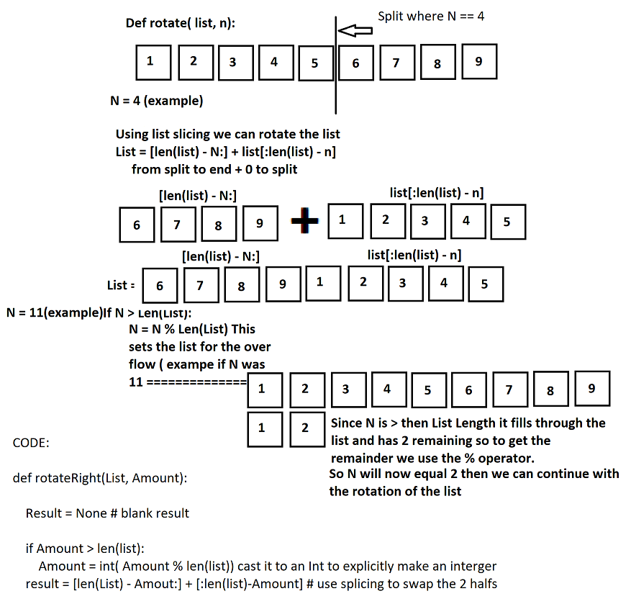

Remember: You need to submit the following code files in addition to this document:

* 01-prove_multiples_of.py
* 01-prove_rotate_list_right.py